**Structure of the Focus Group (4 sections):**

1. **(5 minutes)** Introduction of R and Shiny
2. **(25 minutes)** Introduction of the Learning Analytics Package and its Shiny Interface
3. **(20 minutes)** User experience evaluation
4. **(10 minutes)** Open questions and suggestions

|  |
| --- |
| **Objectives of Learning Analytics Package and Dashboard:** |
| 1. Understand the items in low-stake online quizzes to improve the design of future quiz items 2. Monitor the performance of the students in different levels: individual, per quiz and per group |

**(5 minutes) Introduction of R and Shiny**

In this section a brief introduction to R and Shiny will be given. Some of the packages and the basic structure of Shiny will be introduced.

**(25 minutes) Introduction of the Learning Analytics Package**

In this section, you will be presented with the Learning Analytics Package, the quiz object and the course object will be explained. Also, the tabs in Learning Analytics Dashboard will be explained. For each tab a brief question is asked:

* Do the figures in the **Individual analysis** help you to monitor how an

individual students are performing? What else would you like to understand about the student?

* Do the figures in the **Group analysis** help you to monitor how the group is performing? What else would you like to understand about the group?
* Do the figures in the **Quiz analysis** help you to understand the difficulty of the items as well as the required time per quiz? What are the main points that you consider when designing an item of a quiz?
* Does the **Rasch model** help you to understand the easiness-difficulty of your items?
* Do the associated plots to the Rasch model **(ICC, Person-Item, Person-parameter)** gave you actionable information to improve the design of your quizzes?

**(20 minutes) User experience evaluation**

Now a dataset will be provided and 10 tasks will be given. This section is related to usability, so the central objective is to find if the design is easy to use rather than the interpretation of the plots and data. After completing the tasks a series of affirmations will be given. Please state if you are 1 = Strongly Disagree; 2 = Disagree; 3 = Neutral; 4 = Agree or 5 = Strongly Agree with these affirmations

Tasks:

*Import quizzes tab*

1. Upload the quizzes files
2. Upload the cognitive file and the final exam file
3. Remove the cognitive file and upload it again

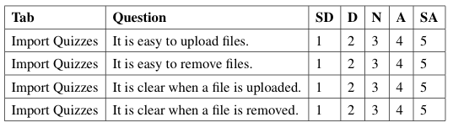

*Display quizzes tab*

1. View if the uploaded files are correct
2. Select the Item and the Cognitive level column for the cognitive file.

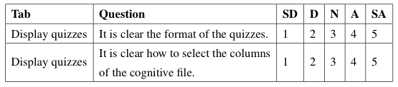

*Individual Analysis tab*

1. Search one student and view its grades.

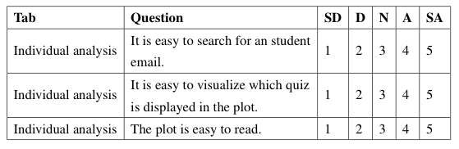

*Group Analysis tab*

1. Select one quiz and view the guessers and order plot

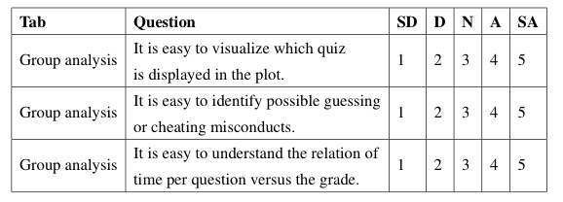

*Quiz Analysis tab*

1. Observe the histogram and boxplot.
2. Observe the ET and ETL plot. Do you see some pattern with the cognitive level?

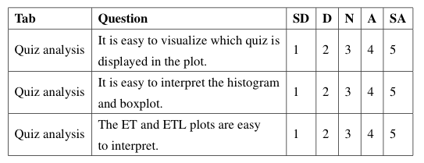

*eRm package tab*

1. Select one file and view the ICC, the person-item map and the person parameters plot.

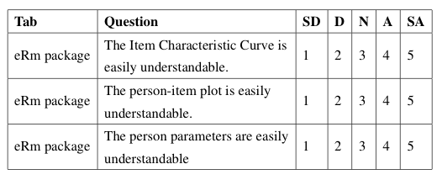

Now please evaluate the following general affirmations (1 = Strongly Disagree; 2 = Disagree; 3 = Neutral; 4 = Agree or 5 = Strongly Agree)

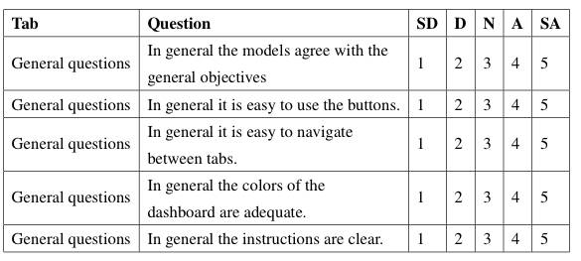

**(10 minutes) Open questions and suggestions**